**WEEK -1 : HANDS-ON EXERCISE**

**Design Principles and Design Patterns**

**Exercise 2: Implementing the Factory Method Pattern**

**INPUT:**

**Document.java:**

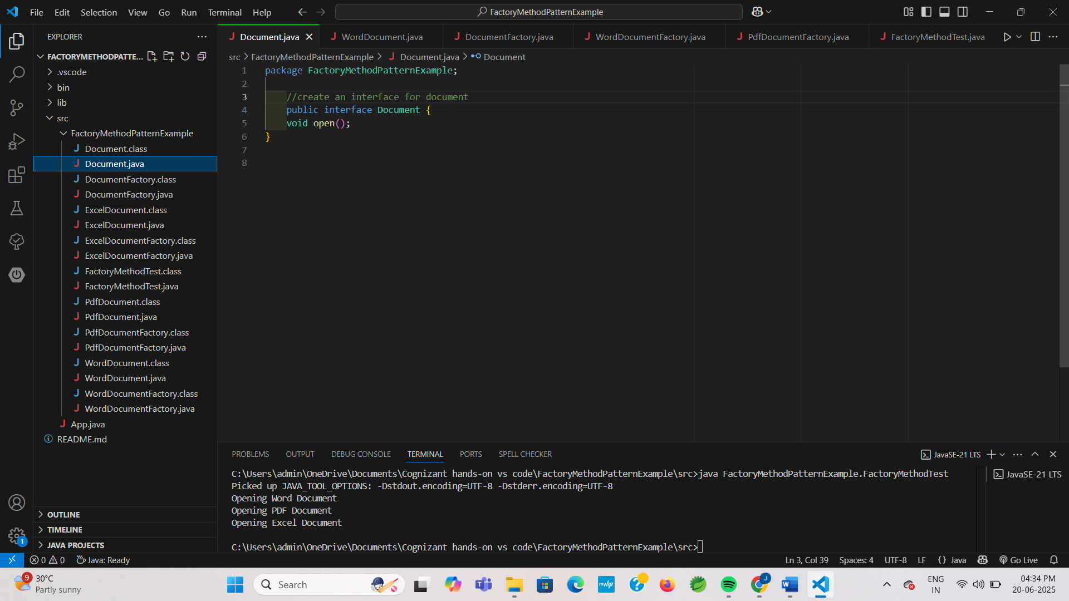

**WordDocument.java:**

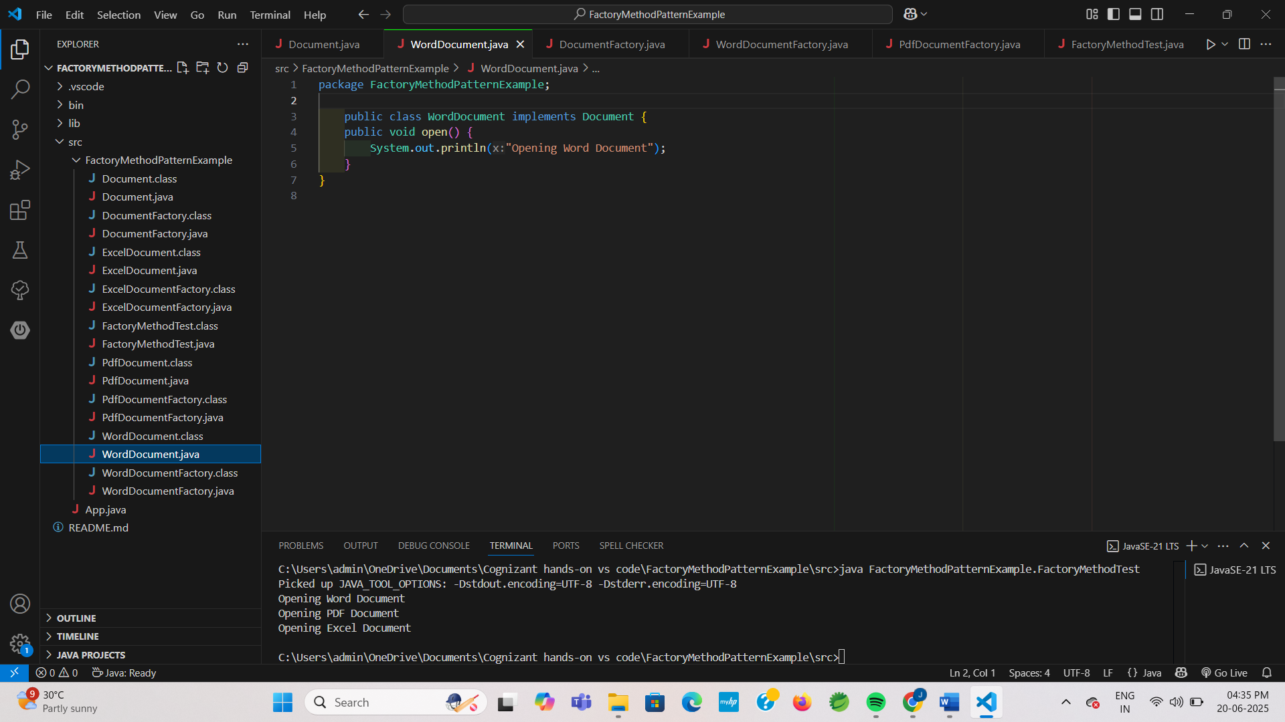

**PdfDocument.java:**

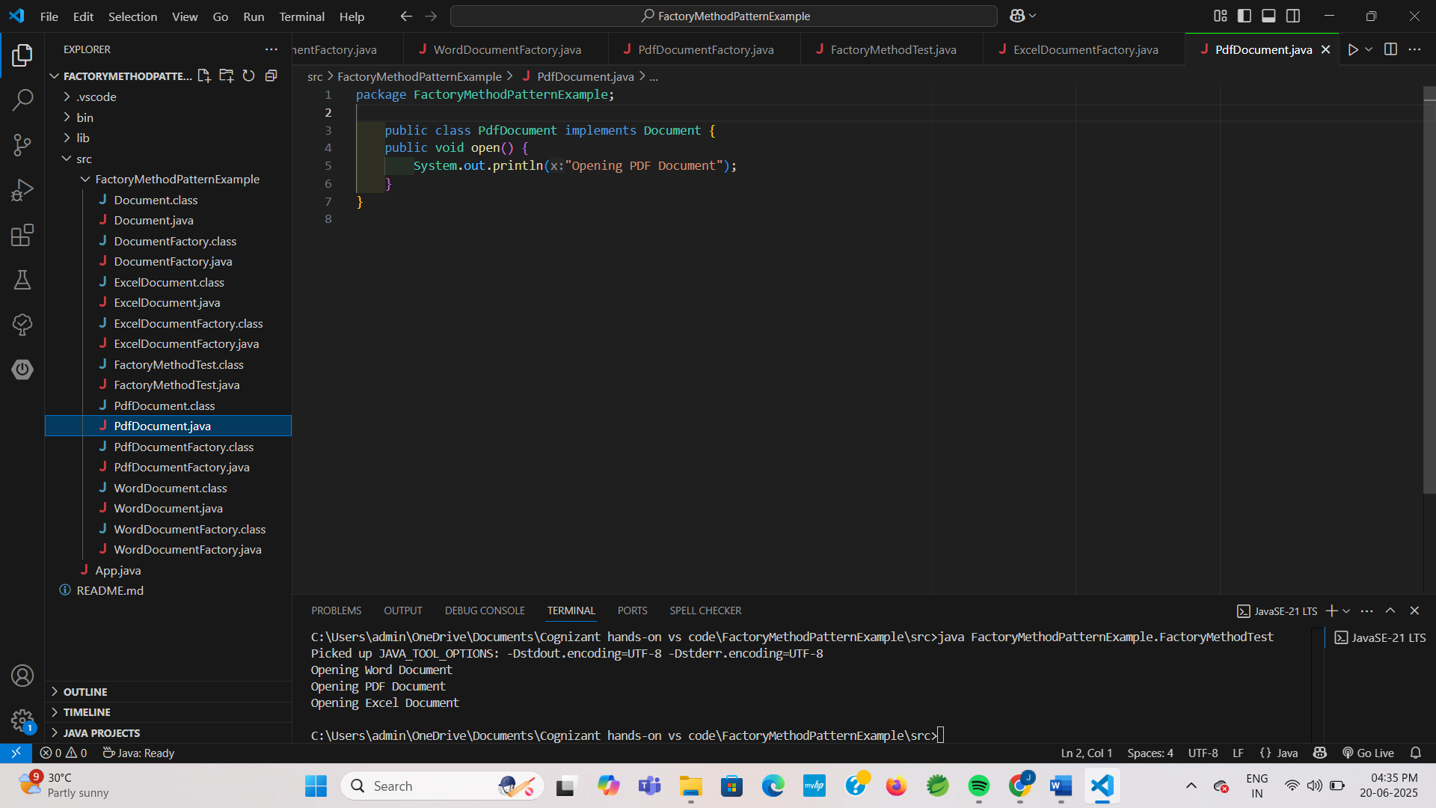

**ExcelDocument.java:**

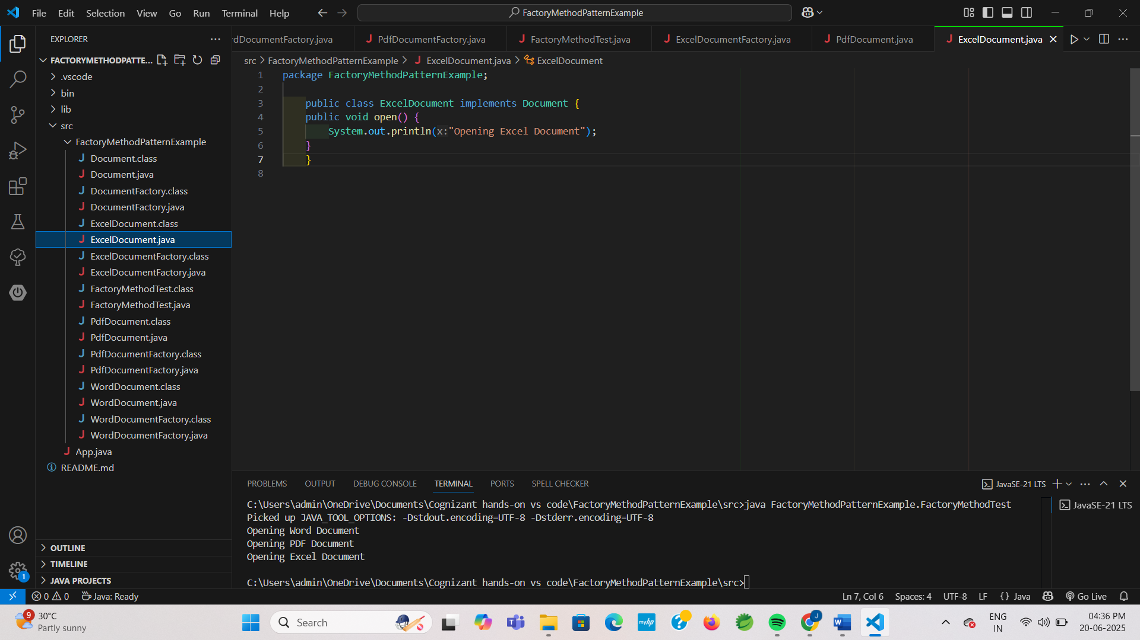

**DocumentFactory.java:**

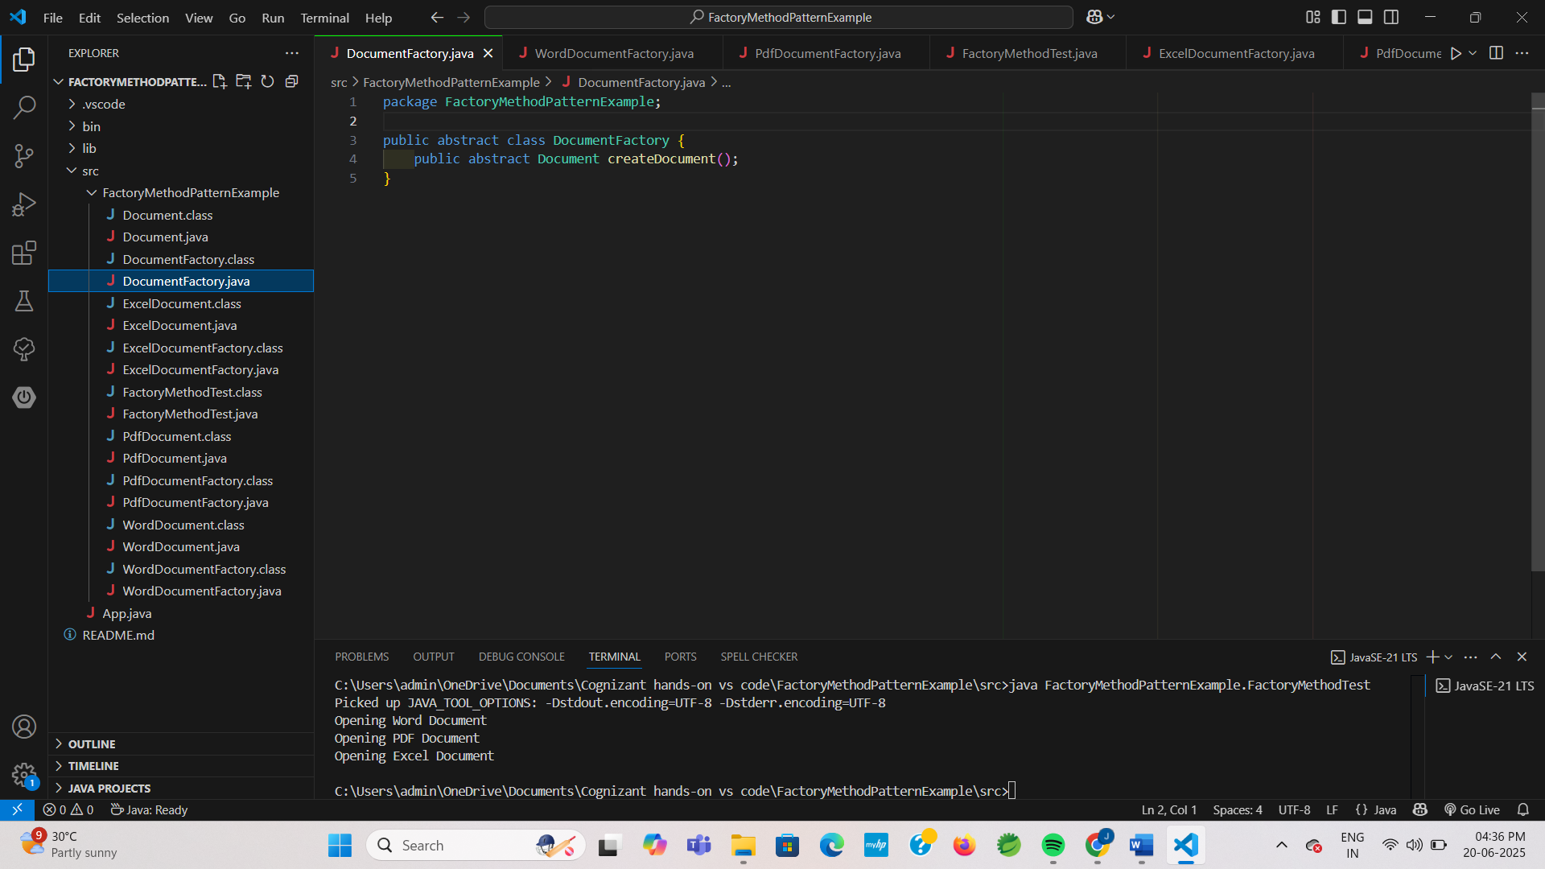

**WordDocumentFactory.java:**

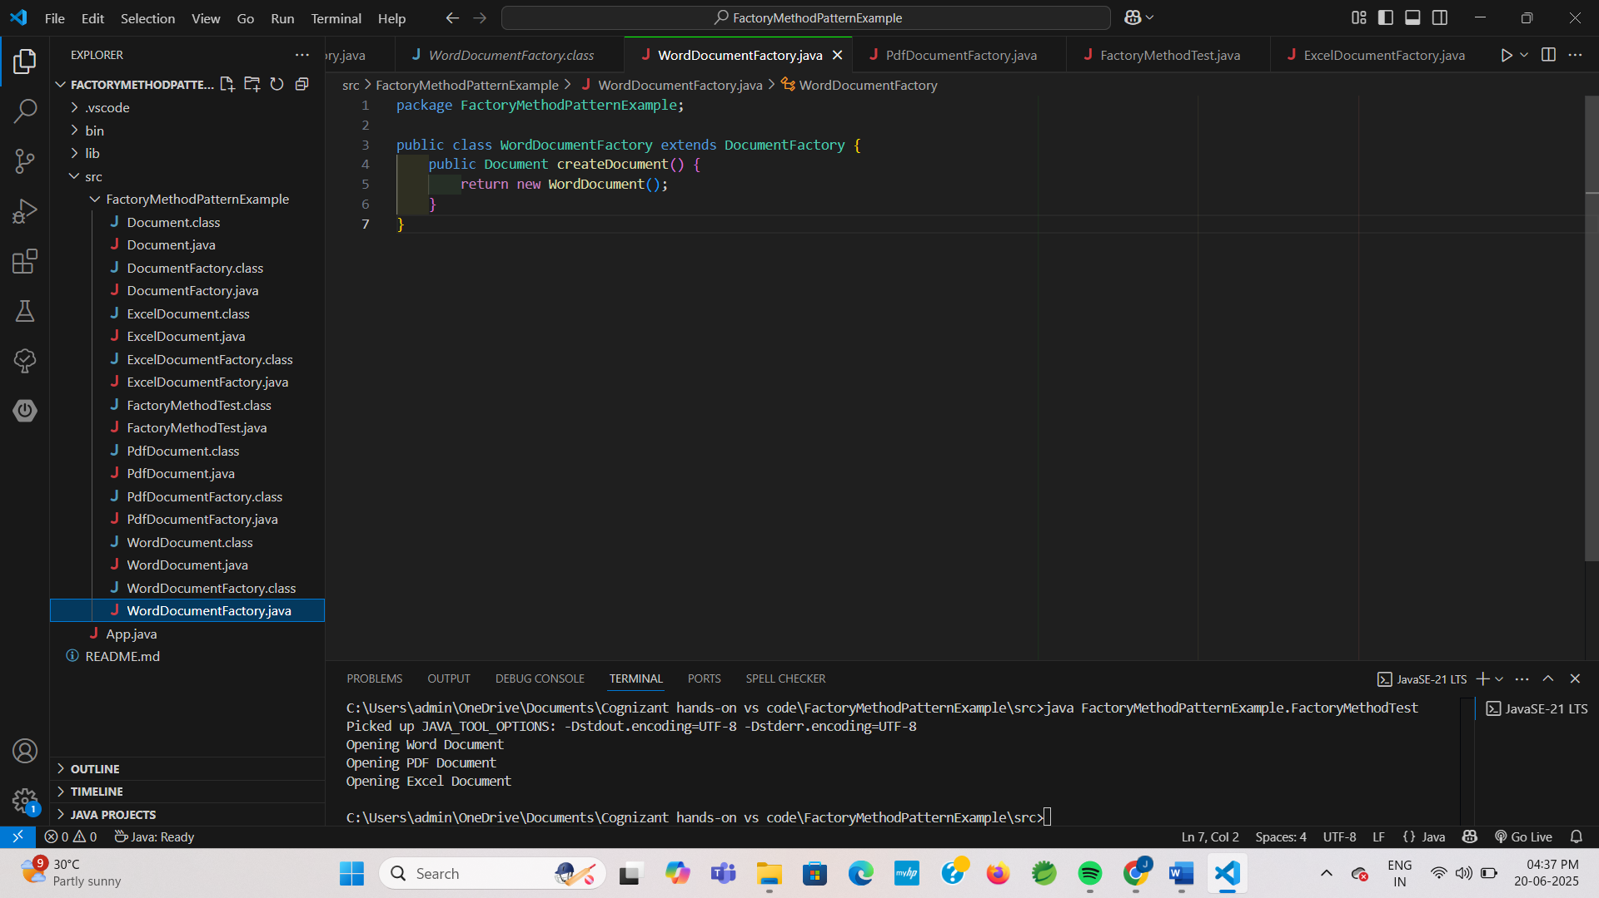

**PdfDocumentFactory.java:**

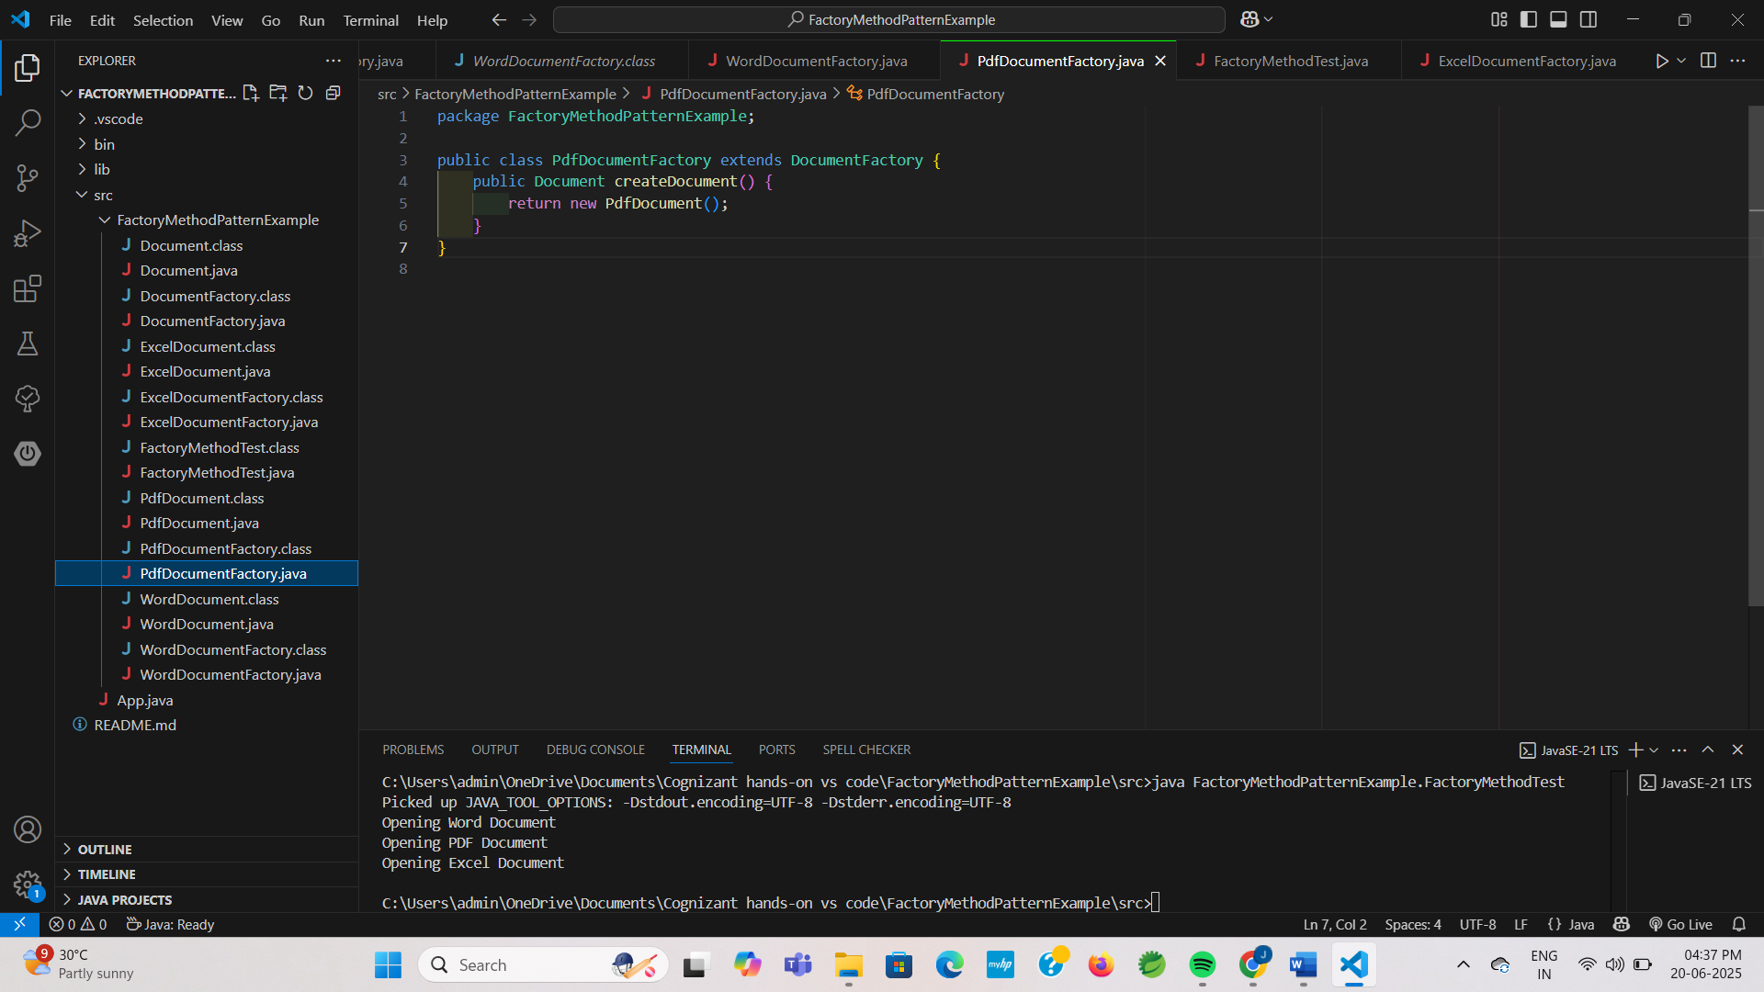

**ExcelDocumentFactory.java:**

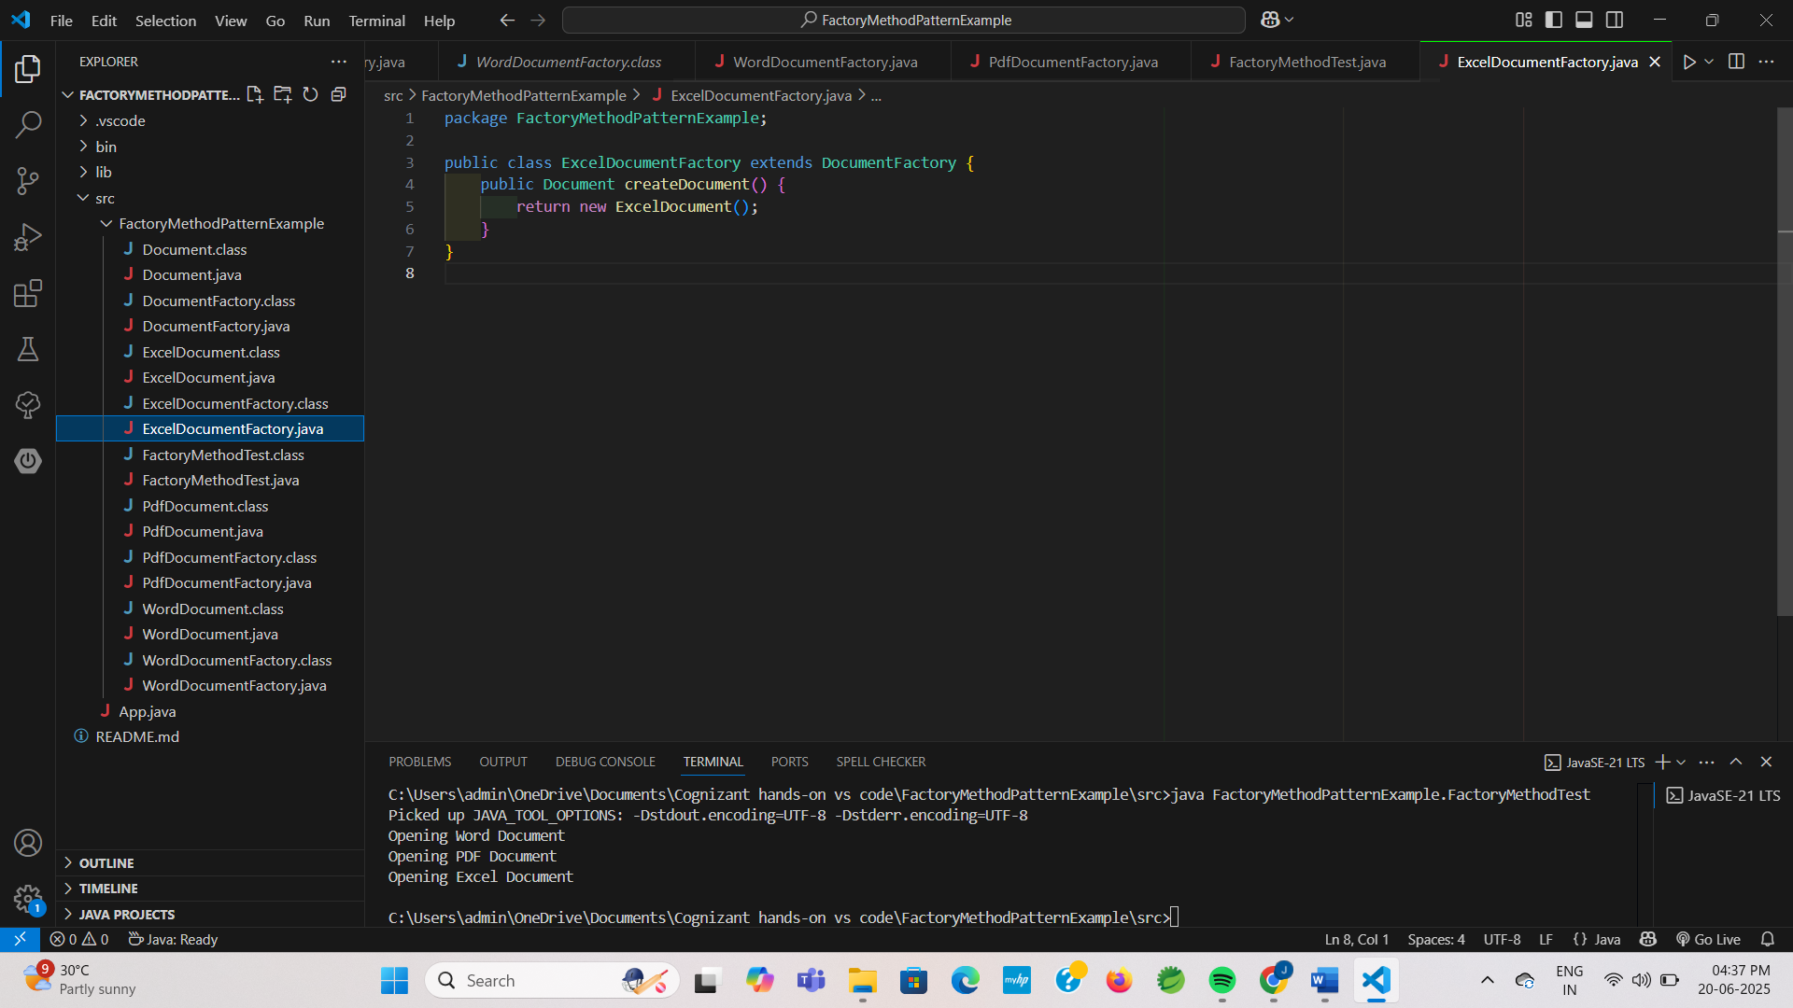

**OUTPUT:**

